Nepal College of information technolgy
Level: Bachelor | Semester – Fall | Year : 2012
Programme: BE |  | Full Marks: 100
Course: Data Mining |  | Time : 3hrs.
Candidates are required to give their answers in their own words as far as practicable.
The figures in the margin indicate full marks.

Attempt all the questions.

 | - What are the issues and challenges of Data Mining?  - Explain different data mining techniques with examples. | 8  7
 | - Why data warehouse is necessary? Why is it called subject-oriented, time variant, integrated and non volatile?  - Write the differences between data warehouse and operational database? | 3+5  7
 | - Explain operation of Decision Support System with figures.  - What is data transformation? Define different data transformation methods: Smoothing, Aggregation, Normalization, Attribute construction. | 7  8
 | - Define the following terms with proper example: Itemset, Support, Confidence, and Frequent Itemset.  - From the data given below,  - Construct a FP-Tree  - Construct Conditional FP tree for item T and find all frequent set from this conditional tree ( Given Minsup =3/6) | 5  5+5
  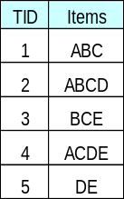TID | ITEMS
  1 | ACTW
  2 | CDW
  3 | ACTW
  4 | ACDW
  5 | ACDTW
  6 | CDT
 | - What is classification?  - By using apriori algorithm, find all the frequent itemset from the following dataset. Show all the steps clearly.  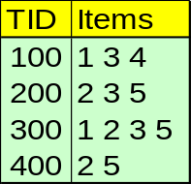  Given: Minsup = 2/4 | 5  10
 | - From the given training dataset, make a decision tree. [Note: only tree is enough, no description required]  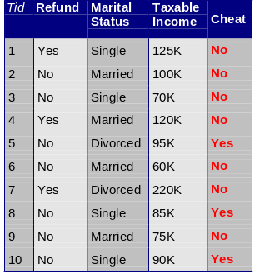  - From the given table, calculate support and confidence.  - 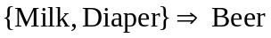  - 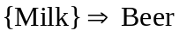 | 7  8
  TID | Items
  1 | Bread, Milk
  2 | Bread, Diaper, Beer, Eggs
  3 | Milk, Diaper, Beer, Coke
  4 | Bread, Milk, Diaper, Beer
  5 | Bread, Milk, Diaper, Coke
 | Write short notes on: (Any Two)  - Supervised Vs Unsupervised learning  - Brute-force approach for frequent itemset generation  - Association Rule | 5×2

